Portfolio 2 – Advanced Prototype & Test Logs

P Number: P2893532
Name: James Masrangi
Individual Component: Budget Management Module
Team Name: Outside the box
GitHub Link: https://github.com/James-lab-code/BUDGET-MANAGEMENT-SYSTEM.git

Contents
1. SQL Server Login Details 2
2. Test Logs 7

SQL Server Login Details
Server Name: v00egd00002l.lec-admin.dmu.ac.uk
User Name: ‘root’;
Password:’ ‘;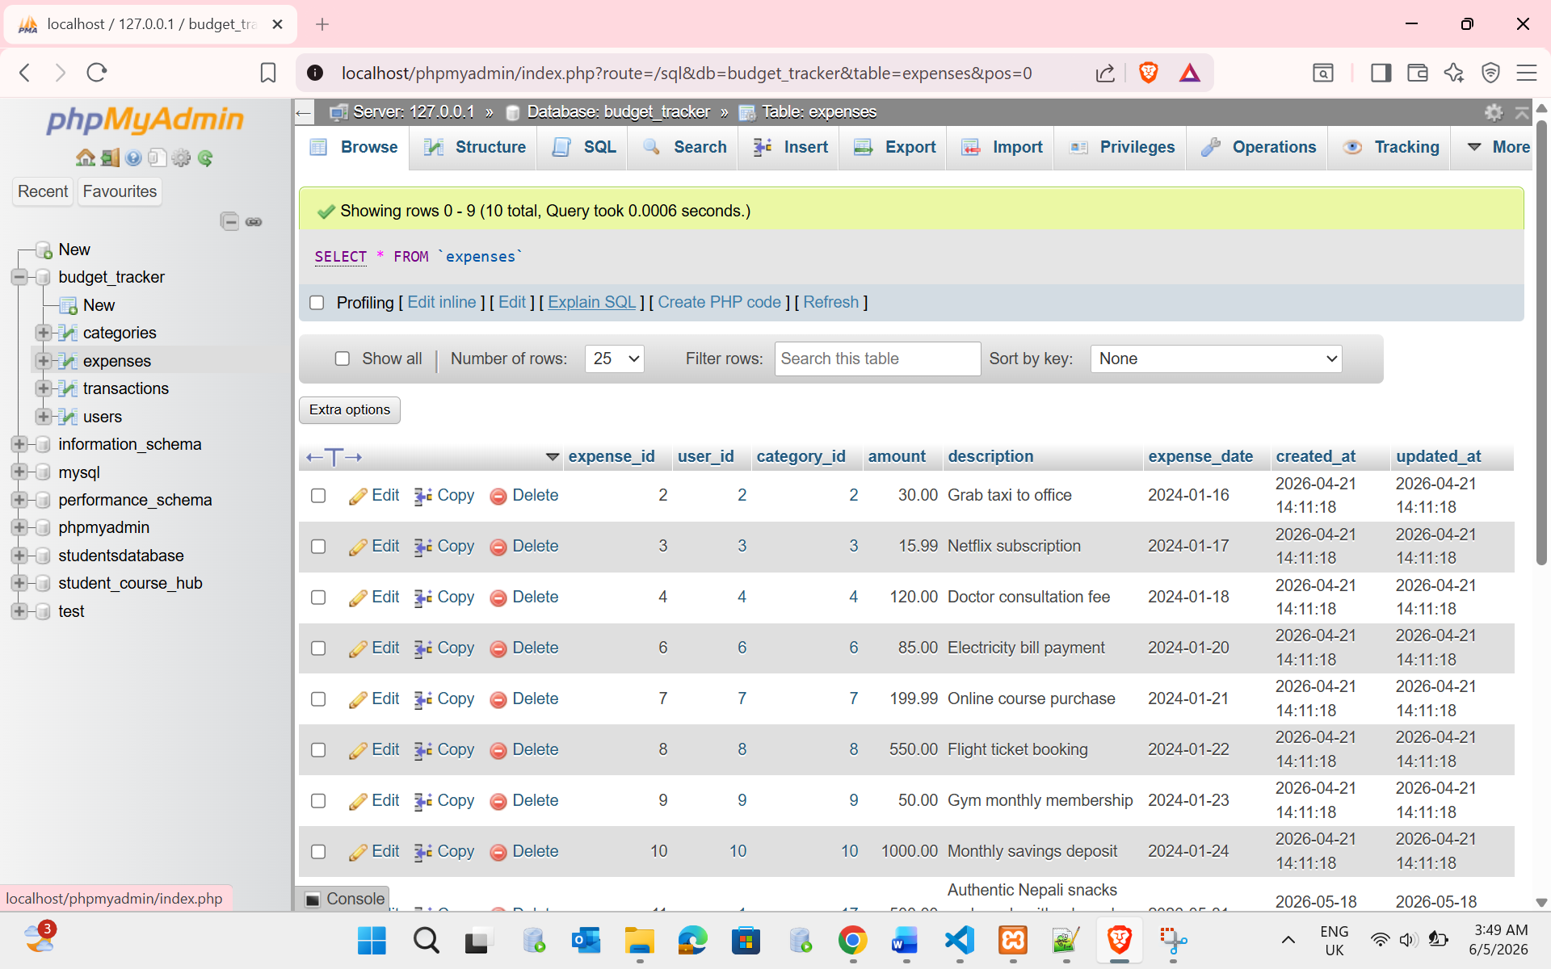
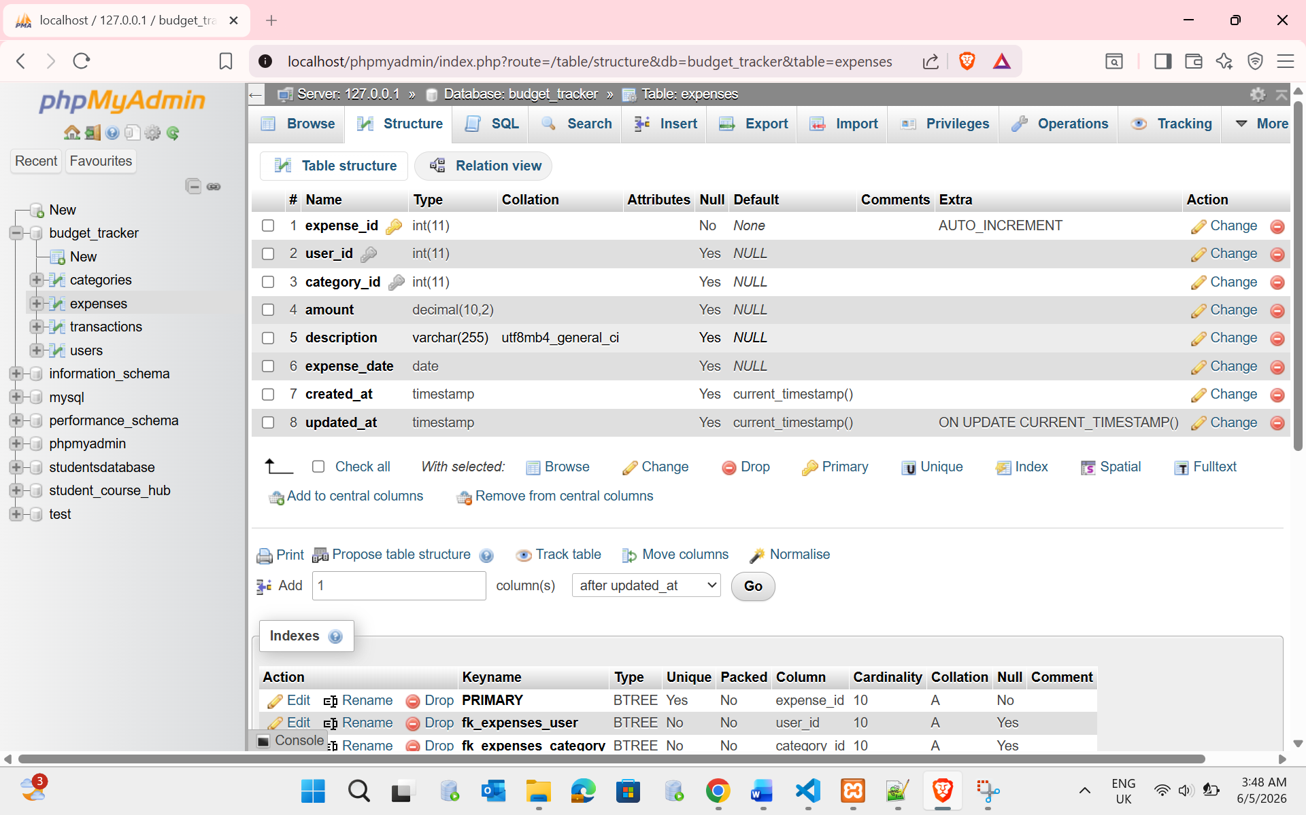
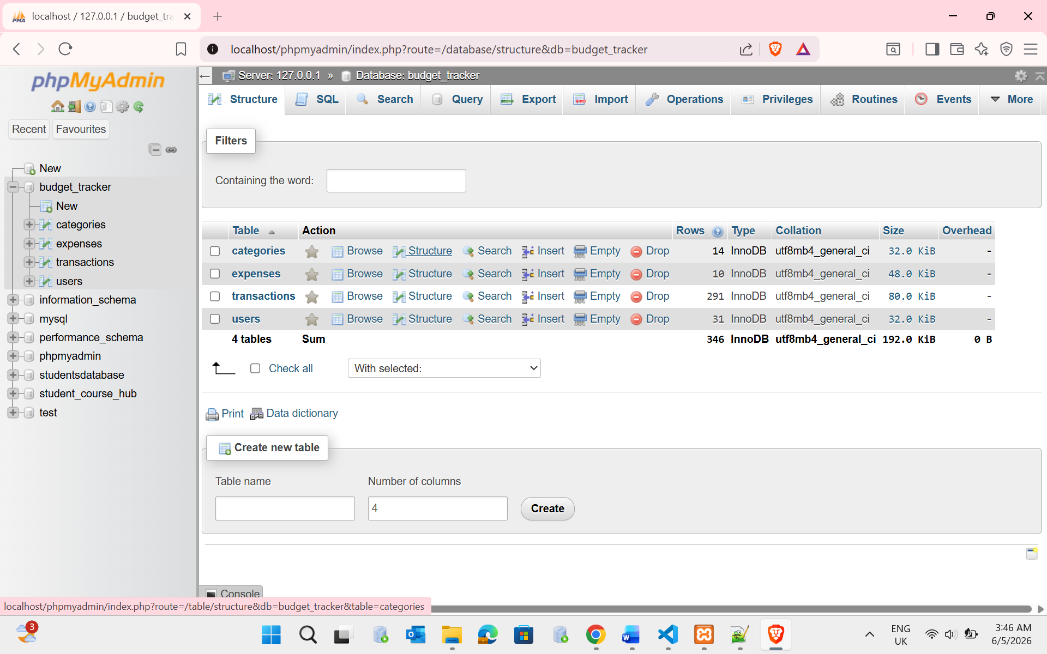

Test Logs

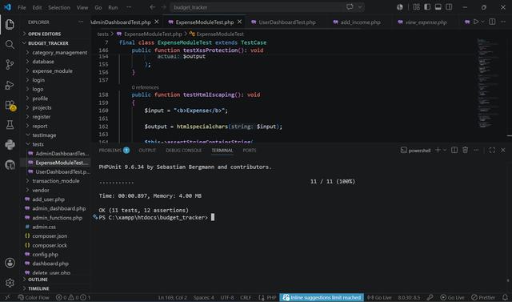

Author of test plan & log: | James Masrangi
Name of tester: | James Masrangi
Date of testing: | 05/06/2026
Description of Item to Be Tested: | Expense Module – Search Expense Transactions
Required Field | Y / N
Business Requirement: | The system shall support expense module – search expense transactions.

Test Type | Test Data | Expected Result | Actual Result
Extreme Min | Minimum valid value | Operation successful | Operation successful
Min -1 | Invalid value | Validation error displayed | Validation error displayed
Min (Boundary) | Boundary value | Operation successful | Operation successful
Min +1 | Above minimum | Operation successful | Operation successful
Max -1 | Below maximum | Operation successful | Operation successful
Max (Boundary) | Maximum value | Operation successful | Operation successful
Max +1 | Above maximum | Validation message displayed | Validation message displayed
Mid | Typical value | Operation successful | Operation successful
Extreme Max | Stress value | System remains stable | System remained stable
Invalid data type | Text input | Validation error displayed | Validation error displayed
Other tests | Additional scenario | Expected behaviour achieved | Expected behaviour achieved
Additional Notes / Instructions: Function operated correctly and matched expected results.

Author of test plan & log: | James Masrangi
Name of tester: | James Masrangi
Date of testing: | 05/06/2026
Description of Item to Be Tested: | Expense Module – Filter Expenses by Date Range
Required Field | Y / N
Business Requirement: | The system shall support expense module – filter expenses by date range.

Test Type | Test Data | Expected Result | Actual Result
Extreme Min | Minimum valid value | Operation successful | Operation successful
Min -1 | Invalid value | Validation error displayed | Validation error displayed
Min (Boundary) | Boundary value | Operation successful | Operation successful
Min +1 | Above minimum | Operation successful | Operation successful
Max -1 | Below maximum | Operation successful | Operation successful
Max (Boundary) | Maximum value | Operation successful | Operation successful
Max +1 | Above maximum | Validation message displayed | Validation message displayed
Mid | Typical value | Operation successful | Operation successful
Extreme Max | Stress value | System remains stable | System remained stable
Invalid data type | Text input | Validation error displayed | Validation error displayed
Other tests | Additional scenario | Expected behaviour achieved | Expected behaviour achieved
Additional Notes / Instructions: Function operated correctly and matched expected results.
Author of test plan & log: | James Masrangi
Name of tester: | James Masrangi
Date of testing: | 05/06/2026
Description of Item to Be Tested: | Expense Module – Sort Expense Transactions
Required Field | Y / N
Business Requirement: | The system shall support expense module – sort expense transactions.

Test Type | Test Data | Expected Result | Actual Result
Extreme Min | Minimum valid value | Operation successful | Operation successful
Min -1 | Invalid value | Validation error displayed | Validation error displayed
Min (Boundary) | Boundary value | Operation successful | Operation successful
Min +1 | Above minimum | Operation successful | Operation successful
Max -1 | Below maximum | Operation successful | Operation successful
Max (Boundary) | Maximum value | Operation successful | Operation successful
Max +1 | Above maximum | Validation message displayed | Validation message displayed
Mid | Typical value | Operation successful | Operation successful
Extreme Max | Stress value | System remains stable | System remained stable
Invalid data type | Text input | Validation error displayed | Validation error displayed
Other tests | Additional scenario | Expected behaviour achieved | Expected behaviour achieved
Additional Notes / Instructions: Function operated correctly and matched expected results.

Author of test plan & log: | James Masrangi
Name of tester: | James Masrangi
Date of testing: | 05/06/2026
Description of Item to Be Tested: | Expense Module – User Authentication
Required Field | Y / N
Business Requirement: | The system shall support expense module – user authentication.

Test Type | Test Data | Expected Result | Actual Result
Extreme Min | Minimum valid value | Operation successful | Operation successful
Min -1 | Invalid value | Validation error displayed | Validation error displayed
Min (Boundary) | Boundary value | Operation successful | Operation successful
Min +1 | Above minimum | Operation successful | Operation successful
Max -1 | Below maximum | Operation successful | Operation successful
Max (Boundary) | Maximum value | Operation successful | Operation successful
Max +1 | Above maximum | Validation message displayed | Validation message displayed
Mid | Typical value | Operation successful | Operation successful
Extreme Max | Stress value | System remains stable | System remained stable
Invalid data type | Text input | Validation error displayed | Validation error displayed
Other tests | Additional scenario | Expected behaviour achieved | Expected behaviour achieved
Additional Notes / Instructions: Function operated correctly and matched expected results.

Author of test plan & log: | James Masrangi
Name of tester: | James Masrangi
Date of testing: | 05/06/2026
Description of Item to Be Tested: | Expense Module – Export Expenses to CSV
Required Field | Y / N
Business Requirement: | The system shall support expense module – export expenses to csv.

Test Type | Test Data | Expected Result | Actual Result
Extreme Min | Minimum valid value | Operation successful | Operation successful
Min -1 | Invalid value | Validation error displayed | Validation error displayed
Min (Boundary) | Boundary value | Operation successful | Operation successful
Min +1 | Above minimum | Operation successful | Operation successful
Max -1 | Below maximum | Operation successful | Operation successful
Max (Boundary) | Maximum value | Operation successful | Operation successful
Max +1 | Above maximum | Validation message displayed | Validation message displayed
Mid | Typical value | Operation successful | Operation successful
Extreme Max | Stress value | System remains stable | System remained stable
Invalid data type | Text input | Validation error displayed | Validation error displayed
Other tests | Additional scenario | Expected behaviour achieved | Expected behaviour achieved
Additional Notes / Instructions: Function operated correctly and matched expected results.

Author of test plan & log: | James Masrangi
Name of tester: | James Masrangi
Date of testing: | 05/06/2026
Description of Item to Be Tested: | Expense Module – Monthly Expense Report Generation
Required Field | Y / N
Business Requirement: | The system shall support expense module – monthly expense report generation.

Test Type | Test Data | Expected Result | Actual Result
Extreme Min | Minimum valid value | Operation successful | Operation successful
Min -1 | Invalid value | Validation error displayed | Validation error displayed
Min (Boundary) | Boundary value | Operation successful | Operation successful
Min +1 | Above minimum | Operation successful | Operation successful
Max -1 | Below maximum | Operation successful | Operation successful
Max (Boundary) | Maximum value | Operation successful | Operation successful
Max +1 | Above maximum | Validation message displayed | Validation message displayed
Mid | Typical value | Operation successful | Operation successful
Extreme Max | Stress value | System remains stable | System remained stable
Invalid data type | Text input | Validation error displayed | Validation error displayed
Other tests | Additional scenario | Expected behaviour achieved | Expected behaviour achieved
Additional Notes / Instructions: Function operated correctly and matched expected results.

Author of test plan & log: | James Masrangi
Name of tester: | James Masrangi
Date of testing: | 05/06/2026
Description of Item to Be Tested: | Expense Module – Dashboard Expense Summary
Required Field | Y / N
Business Requirement: | The system shall support expense module – dashboard expense summary.

Test Type | Test Data | Expected Result | Actual Result
Extreme Min | Minimum valid value | Operation successful | Operation successful
Min -1 | Invalid value | Validation error displayed | Validation error displayed
Min (Boundary) | Boundary value | Operation successful | Operation successful
Min +1 | Above minimum | Operation successful | Operation successful
Max -1 | Below maximum | Operation successful | Operation successful
Max (Boundary) | Maximum value | Operation successful | Operation successful
Max +1 | Above maximum | Validation message displayed | Validation message displayed
Mid | Typical value | Operation successful | Operation successful
Extreme Max | Stress value | System remains stable | System remained stable
Invalid data type | Text input | Validation error displayed | Validation error displayed
Other tests | Additional scenario | Expected behaviour achieved | Expected behaviour achieved
Additional Notes / Instructions: Function operated correctly and matched expected results.

Author of test plan & log: | James Masrangi
Name of tester: | James Masrangi
Date of testing: | 05/06/2026
Description of Item to Be Tested: | Expense Module – Transaction Date Validation
Required Field | Y / N
Business Requirement: | The system shall support expense module – transaction date validation.

Test Type | Test Data | Expected Result | Actual Result
Extreme Min | Minimum valid value | Operation successful | Operation successful
Min -1 | Invalid value | Validation error displayed | Validation error displayed
Min (Boundary) | Boundary value | Operation successful | Operation successful
Min +1 | Above minimum | Operation successful | Operation successful
Max -1 | Below maximum | Operation successful | Operation successful
Max (Boundary) | Maximum value | Operation successful | Operation successful
Max +1 | Above maximum | Validation message displayed | Validation message displayed
Mid | Typical value | Operation successful | Operation successful
Extreme Max | Stress value | System remains stable | System remained stable
Invalid data type | Text input | Validation error displayed | Validation error displayed
Other tests | Additional scenario | Expected behaviour achieved | Expected behaviour achieved
Additional Notes / Instructions: Function operated correctly and matched expected results.

Author of test plan & log: James Masrangi
Name of tester: James Masrangi
Date of testing: 05/06/2026
Description of Item to Be Tested: : Expense Module – View, Edit and Delete Expense Transactions

Required Field Y / N
Business Requirement: The system shall allow users to view, edit and delete existing expense transactions.
Test Type | Test Data | Expected Result | Actual Result
Extreme Min | Edit amount = £0.01 | Transaction updated successfully | Transaction updated successfully
Min -1 | Empty amount field | Validation error displayed | Validation error displayed
Min (Boundary) | Amount = £1.00 | Transaction updated successfully | Transaction updated successfully
Min +1 | Amount = £2.00 | Transaction updated successfully | Transaction updated successfully
Max -1 | Amount = £9,998.99 | Transaction updated successfully | Transaction updated successfully
Max (Boundary) | Amount = £9,999.99 | Transaction updated successfully | Transaction updated successfully
Max +1 | Amount = £10,000.00 | Transaction updated successfully | Transaction updated successfully
Mid | Amount = £500.00 | Transaction updated successfully | Transaction updated successfully
Extreme Max | Amount = £999,999.99 | System remains stable | System remained stable
Invalid data type | Amount = XYZ | Validation error displayed | Validation error displayed
Other tests | Delete existing transaction | Transaction removed successfully | Transaction removed successfully
Additional Notes / Instructions: Edited transactions reflected updated values immediately. Deleted transactions were permanently removed from the transaction list and database records.

Author of test plan & log: James Masrangi
Name of tester: James Masrangi
Date of testing: 05/06/2026
Description of Item to Be Tested: Expense Module – Budget Limit Validation

Required Field Y / N
Business Requirement: The system shall prevent users from recording expenses that exceed the allocated monthly category budget.
Test Type | Test Data | Expected Result | Actual Result
Extreme Min | Remaining Budget = £1.00 | Expense accepted | Expense accepted
Min -1 | Expense exceeds budget by £0.01 | Budget exceeded message displayed | Budget exceeded message displayed
Min (Boundary) | Expense exactly equals remaining budget | Expense accepted | Expense accepted
Min +1 | Expense below budget limit | Expense accepted | Expense accepted
Max -1 | Budget = £9,998 | Expense accepted | Expense accepted
Max (Boundary) | Budget = £9,998 | Expense accepted | Expense accepted
Max +1 | Expense exceeds budget | Budget exceeded message displayed | Budget exceeded message displayed
Mid | Budget = £500, Expense = £250 | Expense accepted | Expense accepted
Extreme Max | Budget = £999,999 |  | Expense accepted
Invalid data type | Text entered as amount | Validation error displayed | Validation error displayed
Other tests | Negative amount entered | Validation error displayed | Validation error displayed
Additional Notes / Instructions: System correctly calculated remaining budget and blocked overspending. Appropriate warning messages were displayed to the user.

Author of test plan & log: James Masrangi
Name of tester: James Masrangi
Date of testing: 05/06/2026
Description of Item to Be Tested: Expense Module – Add Expense Functionality

Required Field Y / N
Business Requirement: The system shall allow authenticated users to add expense records and store them successfully in the database.

Test Type | Test Data | Expected Result | Actual Result
Extreme Min | Amount = £0.01 | Expense saved successfully | Expense saved successfully
Min -1 | Amount = £0.00 | Validation error displayed | Validation error displayed
Min (Boundary) | Amount = £1.00 | Expense saved successfully | Expense saved successfully
Min +1 | Amount = £2.00 | Expense saved successfully | Expense saved successfully
Max -1 | Amount = £9,998.99 | Expense saved successfully | Expense saved successfully
Max (Boundary) | Amount = £9,999.99 | Expense saved successfully | Expense saved successfully
Max +1 | Amount = £10,000.00 | Expense saved successfully | Expense saved successfully
Mid | Amount = £250.00 | Expense saved successfully | Expense saved successfully
Extreme Max | Amount = £999,999.99 | System remains stable | System remained stable
Invalid data type | Amount = ABC | Validation error displayed | Validation error displayed
Other tests | Empty Description Field | Required field error displayed | Required field error displayed
Additional Notes / Instructions: Verified that records were inserted into both Expenses and Transactions tables. Input validation operated correctly and prevented invalid submissions.

